

**StoreOnce**

**Plugin Configuration Guide**

Contents

StoreOnce Configuration Checklist 2

Supported Collection Types 2

Data Sources 2

Requirements 2

Network Ports 2

User Configuration & Bocada Setup 2

Bocada Setup 3

Server Properties 3

Field Definitions 3

Reporting Notes 4

StoreOnce Copy Job Reports 4

StoreOnce Storage is in Dedicated Reports and Standard Bocada Reports 4

Technical Support 9

# StoreOnce Configuration Checklist

While detailed steps are included below, this is an overview of the steps to configure StoreOnce collections on your Bocada Data Collection Server:

* Open port through firewall from Bocada to StoreOnce on port 443
* Obtain credentials for user with the required permissions

# Supported Collection Types

The plugin currently supports the following collection types from StoreOnce servers:

|  |  |  |
| --- | --- | --- |
| **Collection Type** | **Supported** | **Description** |
| Backup | ✓ | Collects transactional details about copy jobs. Example metrics include, start times, durations, bytes, files, errors etc. |
| Storage | ✓ | Collects point-in-time inventory information. Example metrics include, total recoverable gigabytes (storage), media volume count, media volume status, etc. |
| Policy |  | Collects and stores information on policy attributes, schedules, storage units, storage groups, storage lifecycle policies and clients. |

# Data Sources

The plugin relies on the following StoreOnce data sources:

* REST API

# Requirements

The Bocada Data Collection Server must be able to connect to the StoreOnce Server on the port(s) listed in the table below.

### **Network Ports**

|  |  |  |
| --- | --- | --- |
| **Service** | **Default Port** | **Note** |
| *­­HTTPS* | 443 | REST API connection through HTTPS to https://<StoreOnce_servername> |

### User Configuration & Bocada Setup

Bocada collects all data for which the supplied user credentials have access. Users can be configured in User-level data access.

# Bocada Setup

### Server Properties

Backup Server Properties determine how the plugin will interface with the StoreOnce server and are managed through the Backup Servers view.

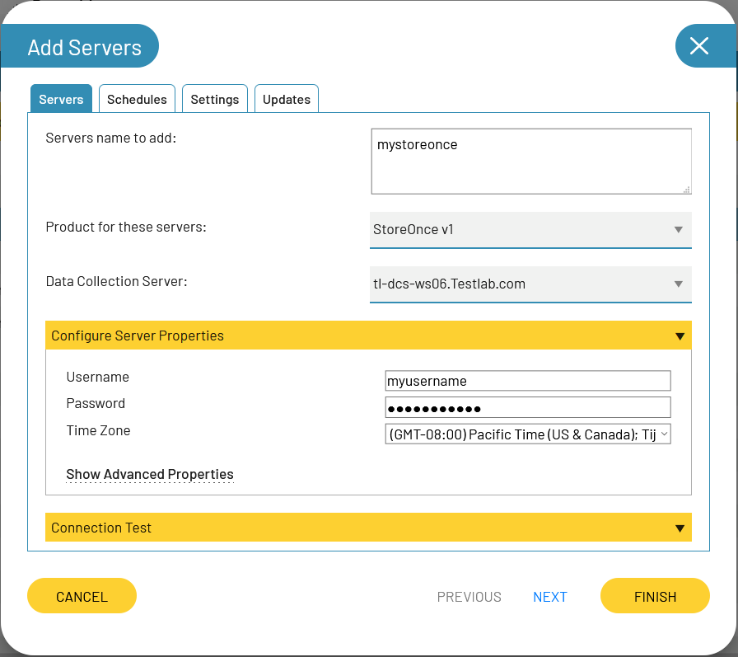

### Field Definitions

#### Username & Password

Enter the username and password for a StoreOnce user.

#### Time Zone

Select the time zone where StoreOnce server resides. This setting defines how job times will be shifted when reporting across different time zones.

# Reporting Notes

### StoreOnce Copy Job Reports

If you are copying data between StoreOnce devices then you will see copy jobs reported in the usual Bocada backup job reports. Those reports, such as Job Trends and Job Activity reports, are described in the Bocada Reporting Guide. You will see jobs reported for both the source StoreOnce and the destination StoreOnce. Job types include:

* Copy Source
* Copy Destination

### StoreOnce Storage is in Dedicated Reports and Standard Bocada Reports

Storage data collection in Bocada is based on a snapshot of the StoreOnce when the data was collected.

#### Dedicated StoreOnce Storage Reports

There are three dedicated StoreOnce storage reports in Bocada:

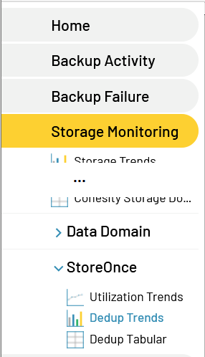

##### StoreOnce Utilization Trends Report

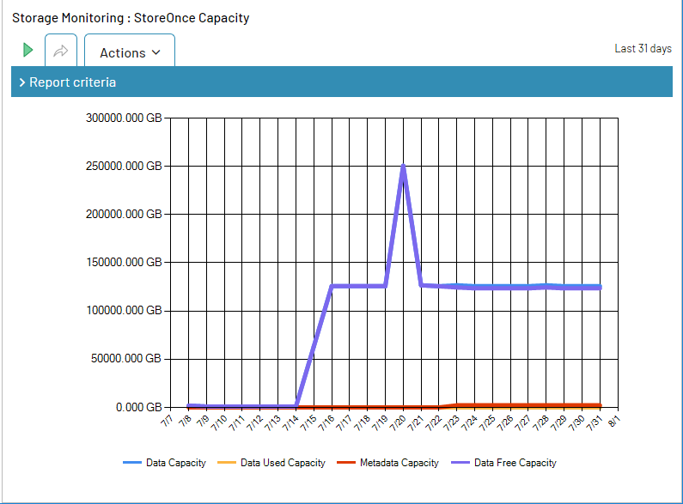

##### StoreOnce Dedup Trends Report

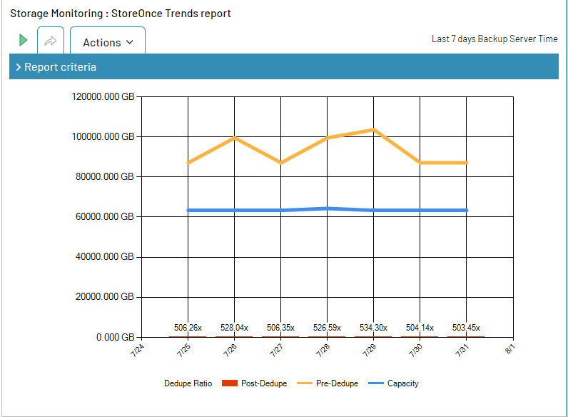

The StoreOnce Dedup Trends report shows only Store/Share/Library data bytes.

* Pre-Dedupe bytes in the report are the User Bytes”
* Post-Dedupe bytes in the report are the Disk Bytes
* Dedupe ratio in Bocada is shown as Pre- Dedupe /Post- Dedupe

##### StoreOnce Trends Tabular Report

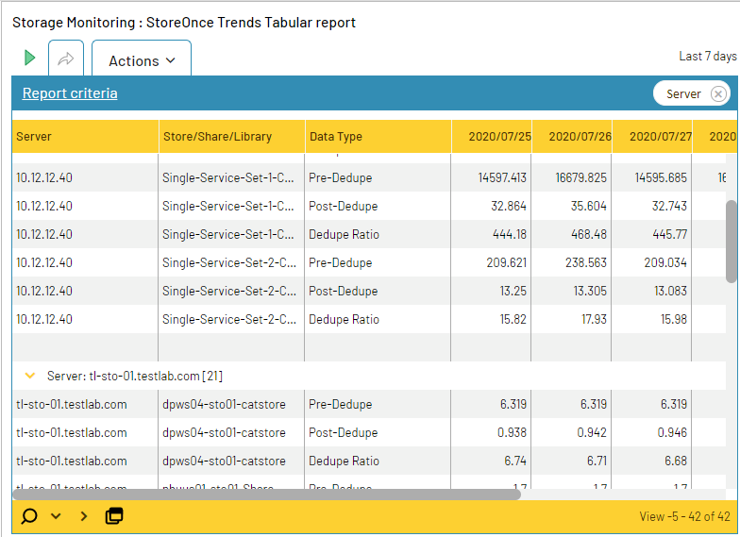

The StoreOnce reports all show bytes in binary GB aka GiB by default, but the selection criteria allows you to select other units, such as TB.

* Pre-Dedupe bytes in the report are the User Bytes
* Post-Dedupe bytes in the report are the Disk Bytes
* Dedupe ratio in Bocada is shown as Pre- Dedupe /Post- Dedupe

#### Standard Bocada Reports for StoreOnce Storage

The Bocada Storage Servers report shows the StoreOnce capacity and usage. The count of volumes is a count of Service Sets in StoreOnce.

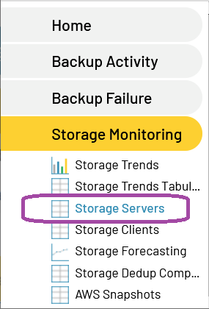

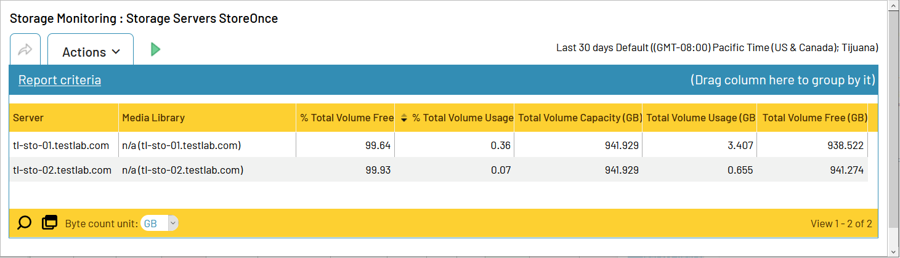

# Technical Support

For technical support or a copy of our standard support agreement, please contact us.

**E-mail:**[support@bocada.com](mailto:support@bocada.com)

**Support Portal:**<https://bocada-support.force.com/>

**Phone:**+1 425-898-2400